1.17: a) The average volume is
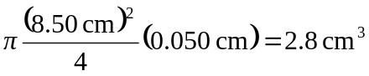
(two significant figures) and the uncertainty in the volume, found from the extreme values of the diameter and thickness, is about 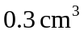, and so the volume of a
cookie is 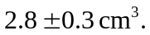 (This method does not use the usual form for progation of errors, which is not addressed in the text. The fractional uncertainty in the thickness is so much greater than the fractional uncertainty in the diameter that the fractional uncertainty in the volume is 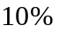, reflected in the above answer.)

b) 